June 1, 2023

E0121051 - SwameNathan Balaji AI&ML 2nd Year

1. Sum of profit sales in each state:

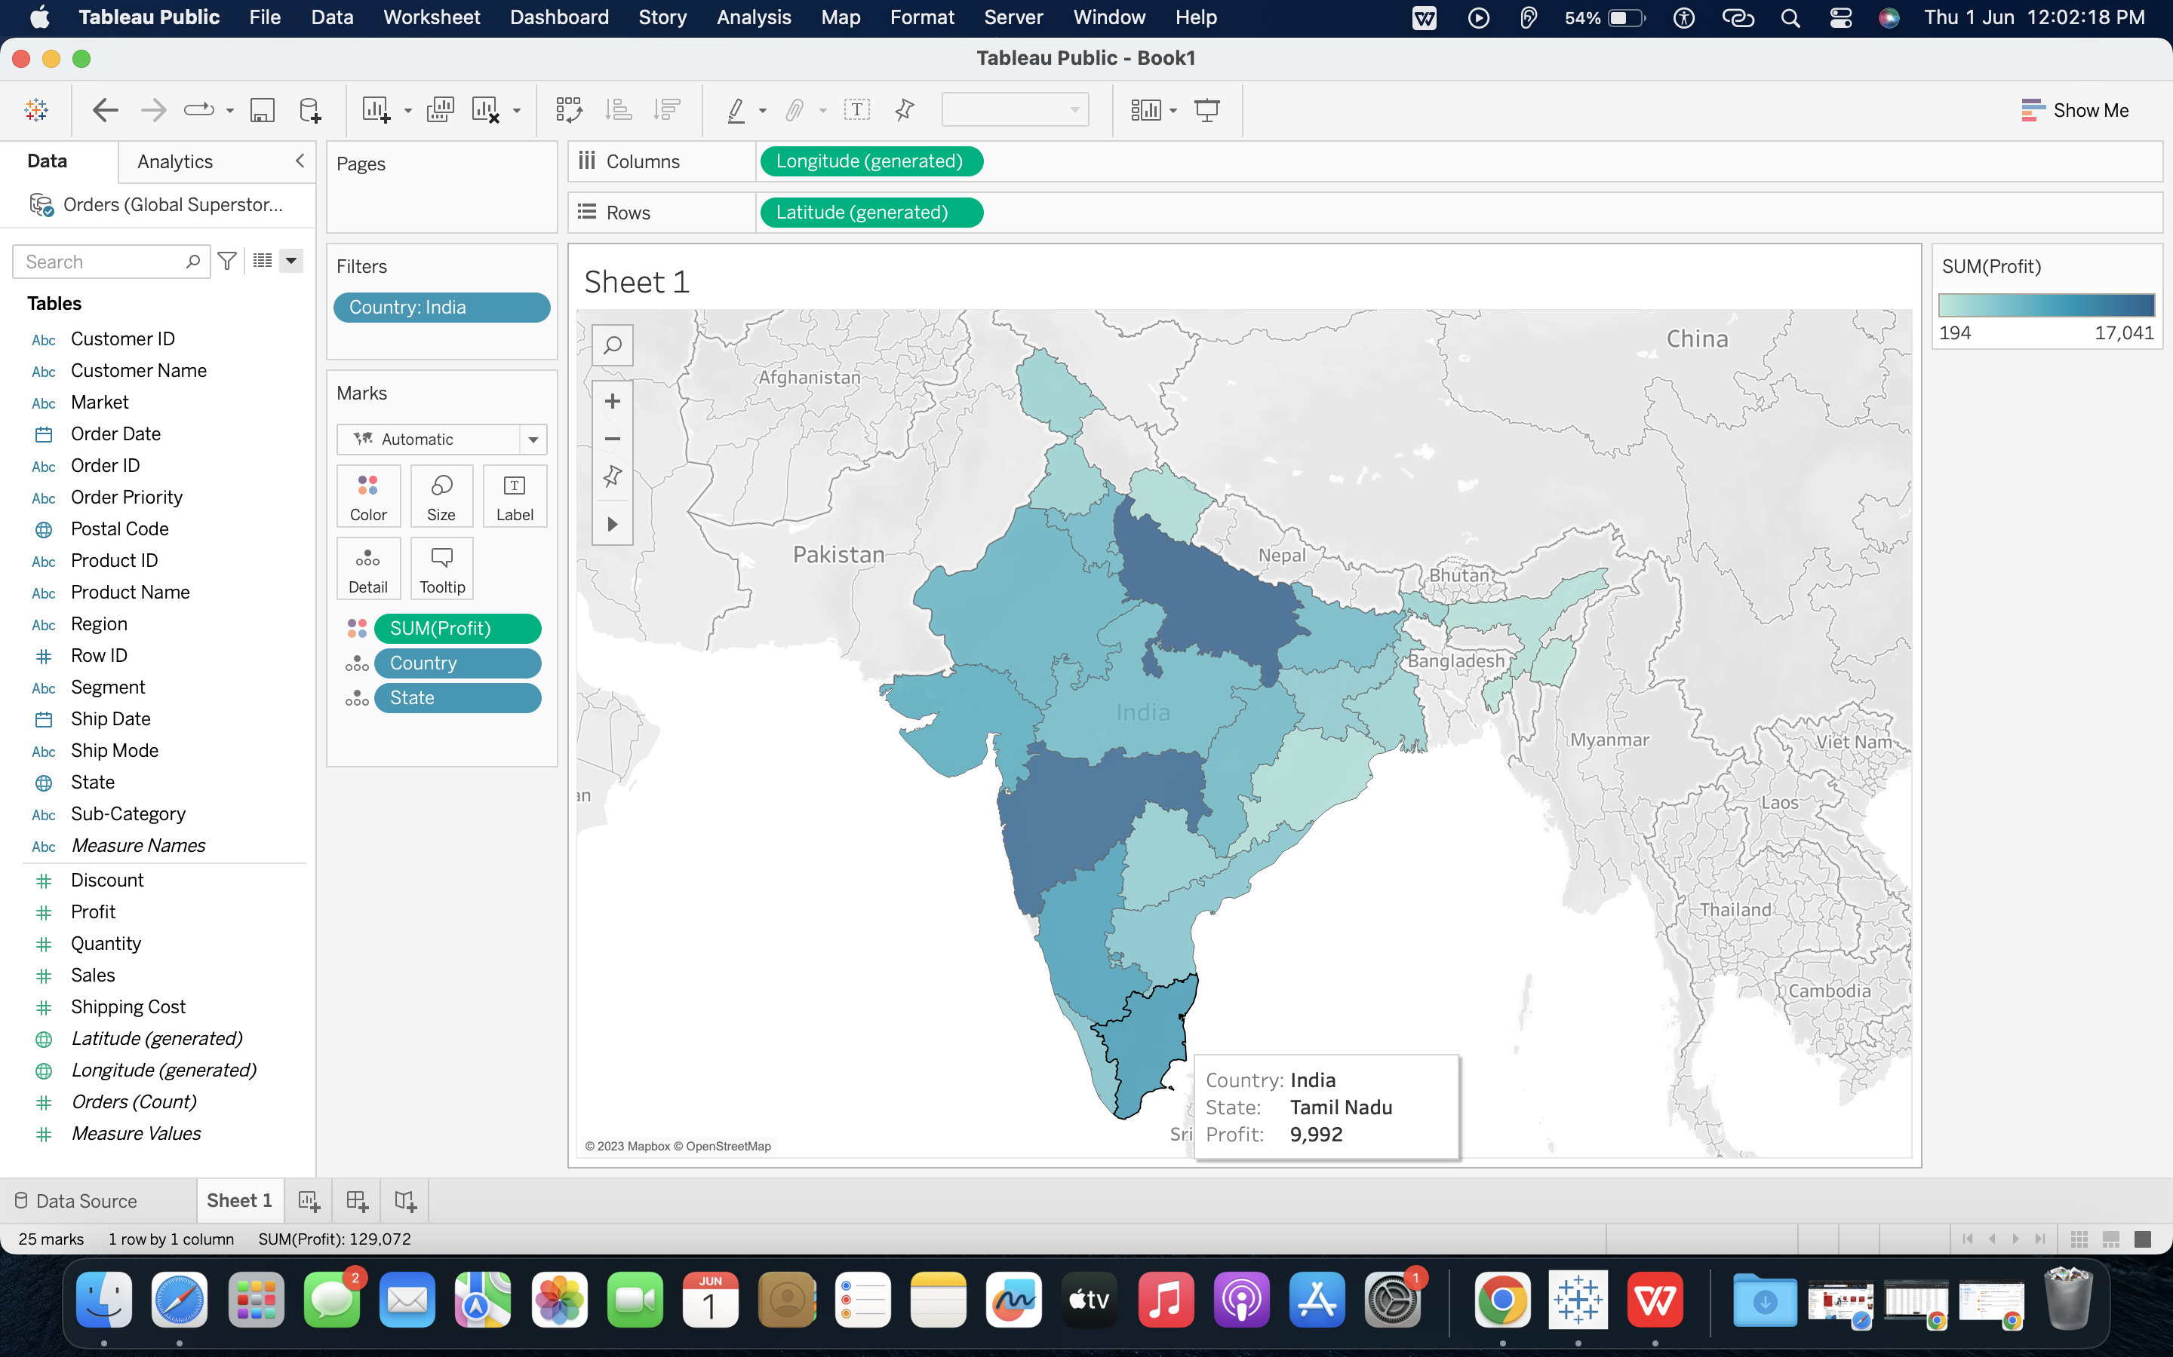

1. With symbols:

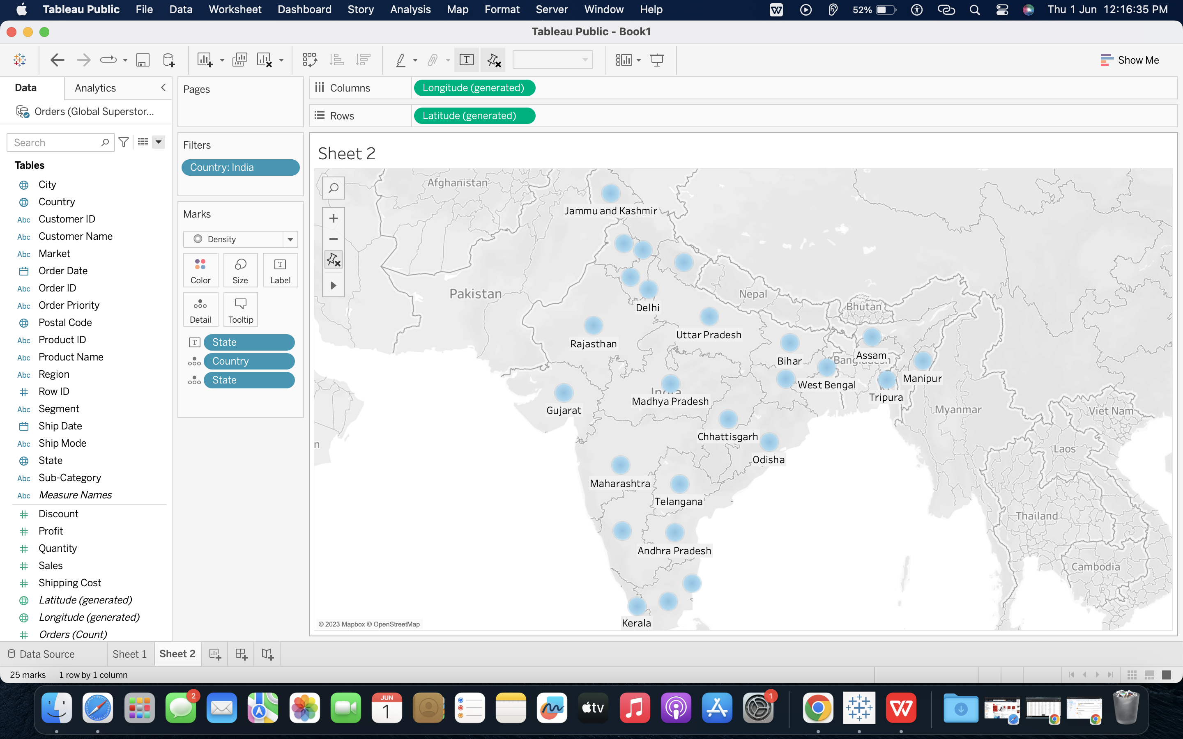

1. With different shapes & Colors:

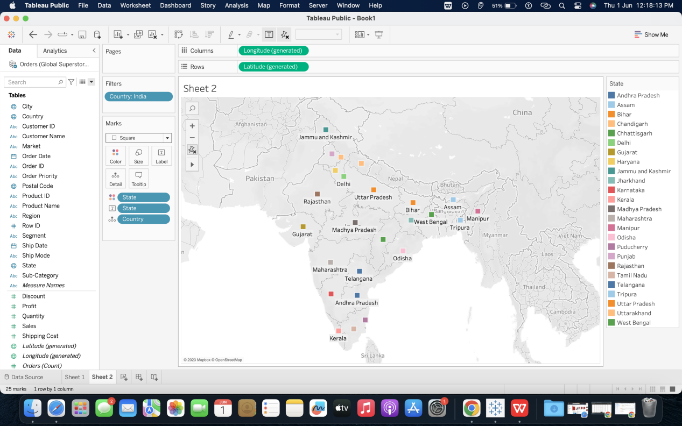

1. STATES WITH DIFFERENT COLORS OF PROFIT:

